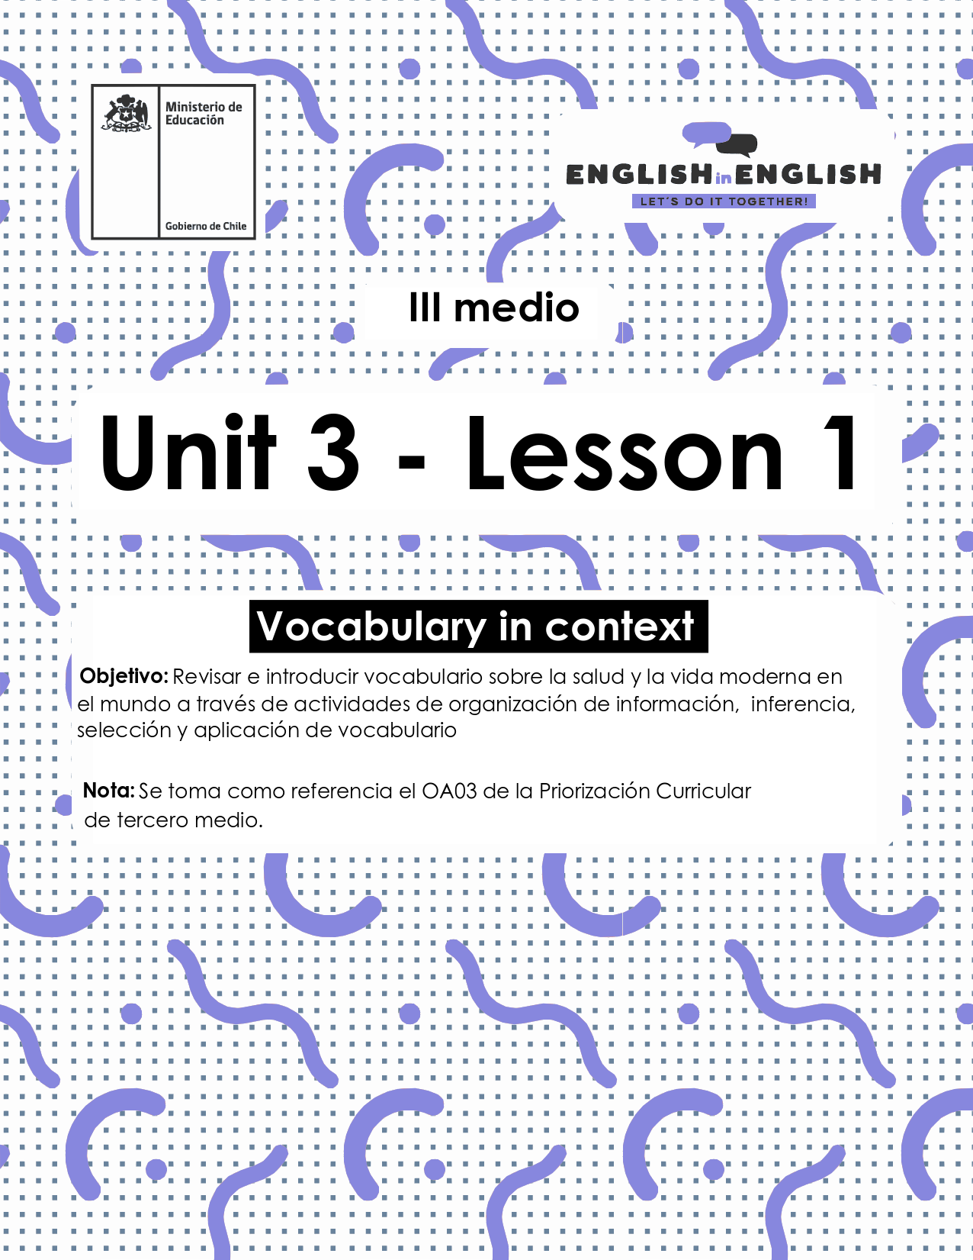

UNIDAD 3
LESSON 1

ÚTILES

- Texto del estudiante de 3° medio.
- Diccionario de inglés.
- Lápices.
- Cuaderno de asignatura.

ICONS FOR ACTIONS

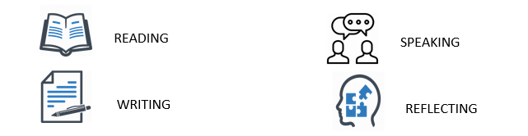

SECTION 1: SETTING THE CONTEXT: 

Hello everyone! Welcome to unit number 3. In this unit we will cover the topic of good health by considering the current context.

- Look at the picture and answer the following questions.

- Which of the images in the picture reflect your lifestyle?

- What would you add to the image to reflect a healthy lifestyle?

- Do you have a healthy lifestyle? If so, can you tell us why/why not?
.

- What about doing things like exercising, avoiding too much sugar or relaxing to feel good? Do you do any of these? Please explain.

- Many times, doctors and therapists have talked about the importance of taking care of ourselves by avoiding or promoting certain actions in daily life. Read the following words/phrases and classify them into the following chart:

Super foods – jogging – mindfulness – workout – daily treats - soreness – smoking – practice yoga – feeling stressed – always eat breakfast – sleeping well – avoid medical care- take morning walks – high calorie snacks - fun breaks – overthinking - salty food

Good health habits | Bad health habits

SECTION 2: LET´S PRACTICE

- Read the following text about superfoods and then complete the chart with the words from the box:
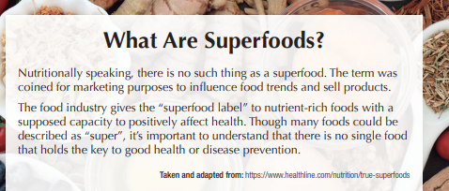
Increases flexibility - Chia - Good Sleeping - Beetroot - Brain fitness - Prevent soreness - Prevent stress - Seaweed - Diet

Superfood examples | Benefits for the body (Physical health) | Benefits for the mind (Mental health)

- Read the following statements and write if you “agree” (A) or disagree (D) according to your opinion:
A _____ Some of the benefits of practicing sports are feeling good and staying in shape.
B ______ Some food like avocado, chia and pomegranate help to keep brain’s fitness.
C ______ Feeling stressed and anxious can affect your brain.
D ______ Life expectancy only depends on good sleep habits.
E ______ Having a diet just refers to eating fruit and vegetables.
F ______ Mindfulness and yoga are just for children or young people.

- How many “agree” or “disagree” statements did you subscribe? Do you agree with all of them? Choose 3 of them and complete the sentences:

- I agree with sentence ___ because________________________.

- I disagree with sentence _____because_______________________.

- I think sentence_____ is right because_______________________.

- Read Roberto´s description about his healthy habits over the COVID-19 pandemic and complete the missing vocabulary with words from this worksheet. Pay attention to the letter clue 😉.

Over the COVID-19 pandemic, I have made big efforts to keep a H______ lifestyle. Every morning, I wake up at 8:00, I have breakfast, and I do E______ to stretch my muscles and be F______. After that I have bread and milk for breakfast, and I always eat A______ which is a super food. I care a lot about my D_____ because this can prevent S______ which is bad for my productivity. I additionally, S_____ from 7 to 8 hours a day.

SECTION 3: LET´S CONSTRUCT AND APPLY OUR KNOWLEDGE
- Can you name some of the activities you are doing to keep a good mental health during the quarantine?
1.___________________________________________________
2.___________________________________________________
3.___________________________________________________

- A healthy lifestyle has both short- and long-term health benefits. Can you list some of them? Use the vocabulary from the worksheet to help yourself.
Short term health benefit | Long term health benefit
For example:  - Better health makes you feel strong. | For example:  - It helps you live longer.

