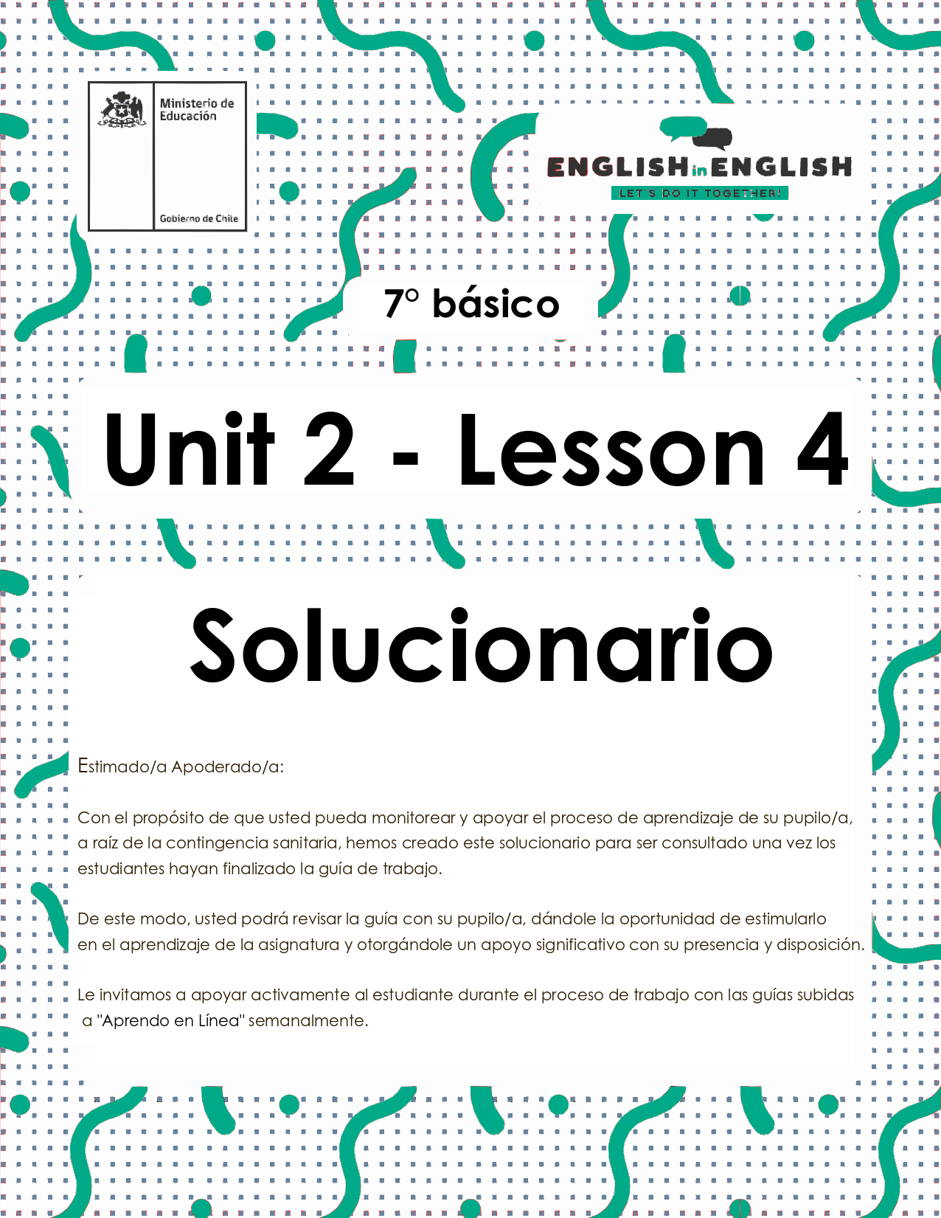
UNIT 2
LESSON 4

ÚTILES RECOMENDADOS:
- Texto del estudiante 7° básico.
- Cuaderno de inglés o 2 hojas en blanco.
- Lápiz grafito y goma.
- Diccionario de Inglés físico / online https://dictionary.cambridge.org/es/diccionario/espanol-ingles/

SECTION 1: SETTING THE CONTEXT
Healthy Habits

1. Read this statement and answer.
- Lee este enunciado y responde.

“Taking care of your body is taking care of your mind”
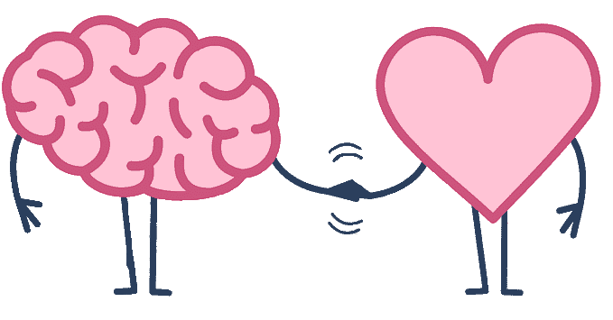

**todas las respuestas son correctas**

- Write 4 words that come to your mind.
Ejemplo de palabras: healthy, food, exercises, physical
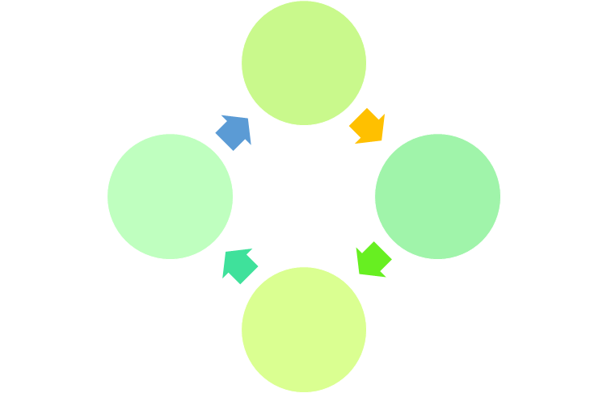

b) How can you apply this statement to your life?
Being concious that I need to have a healthy lifestyle.
c) How should you take care of your body? Give an example
Eating healthy food,doing physical exercises and avoiding stress.

2. Match the concepts with the correct pieces of information. You can use your dictionary.
- Relaciona los conceptos con la información correcta. Puedes usar tu diccionario.

A) to be fit B) healthy habit C) unhealthy food D) breakfast E) preparation F) healthy food

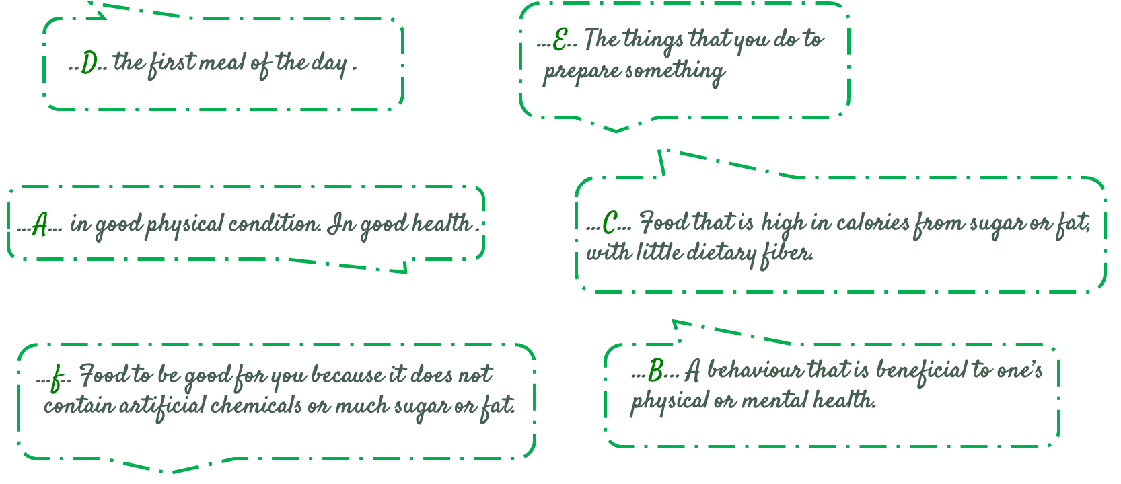

3.

Read these sentences related to habits and decide if they are healthy (H) or unhealthy (U)

- Lee estas oraciones relativas a hábitos y decide si son saludables (H) o no saludables (U).
H
H
U
H
U
H
a) You must eat fruits and vegetables.
b) I drink soda 3 times a day.
c) I practice yoga every morning.
d) You should eat pizza everyday.
e) I like to eat broccoli for lunch.
f) I don´t smoke.
SECTION 2: LET'S PRACTICE
Rachel and Roy
- Read the texts and underline all the food items.
- Lee los textos y subraya las palabras relacionadas a alimentos.
Rachel Hall
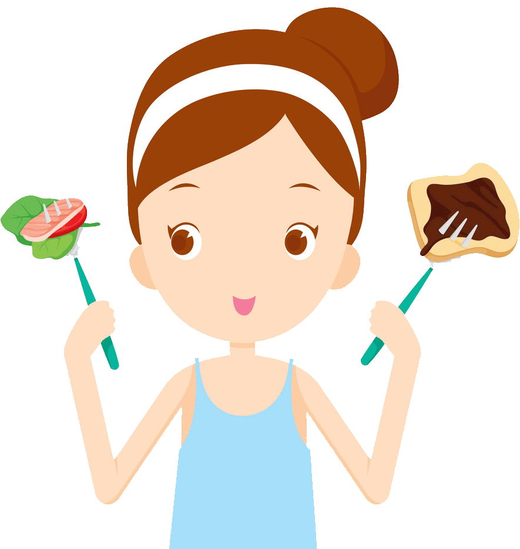
“I usually skip breakfast and have chips, cookies, candy and soda for lunch. I buy it from school vending machines. After school, I often go to a take away restaurant for French fries, fried rice and egg rolls. Dinner at home tends to be much healthier – baked chicken and rice, grilled fish, salads… I know my mom would prefer that I eat healthier meals, but the fact is that I don’t have much time and junk food is often the quickest way to satisfy my hunger when I’m on the go and that’s common among busy teenagers.”

Roy Patel
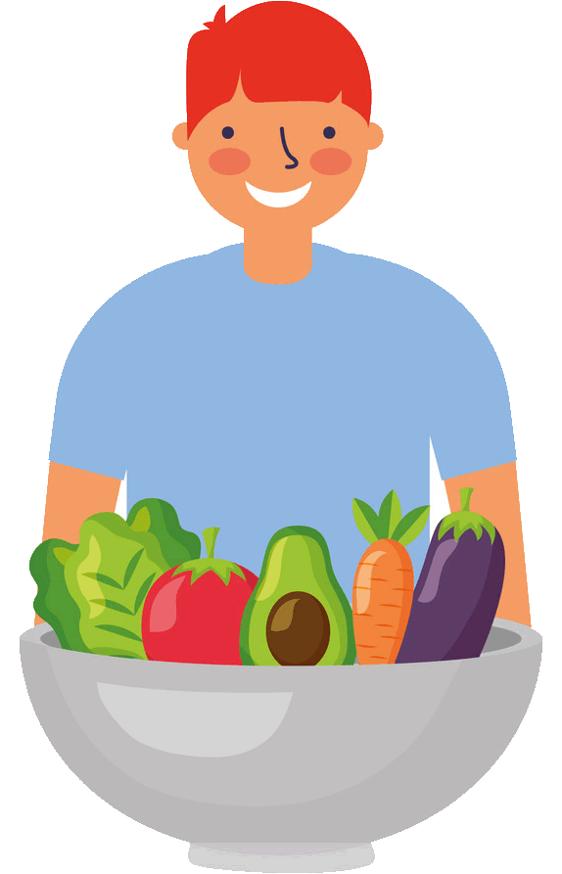
“I am a big fresh fruit eater, which is unusual, I admit, for a 15-year-old. I love citrus fruit, apples, nectarines, kiwi and mango. I never skip breakfast. For me it’s the most important meal of the day. At school I only eat soup and sometimes an apple. I usually come home around 3 o’clock and I have a vegetable salad. I know I do this thanks to my parents’ mealtime routines. When I eat out, I also try to choose healthy dishes, but sometimes I can’t resist some delicious desserts.”

Vocabulary
Skip : saltar, evitar - Vending machine : máquina expendedora - Take away restaurant : comida para llevar - Hunger : hambre - On the go : en movimiento, ocupado/a

Text taken from https://es.scribd.com/document/238223149/Teenagers-Eating-Habits

- Read the texts and write if the sentences are correct (C) or incorrect (I)
- Lee los textos y escribe si las oraciones son correctas(C) o incorrectas (I)

a) Rachel is a healthy girl. I
b) Roy skips meals. I
c) Rachel's school sells junk food. C
d) Roy prefers junk food. I
e) Roy eats soup at school. C
f) Rachel always has breakfast. I

- Read the texts again and complete the table with a tick when corresponds.
- Lee los textos nuevamente y completa la tabla con un cuando corresponda.

 | Rachel | Roy
……. likes fresh fruits.
……. is 15 years old.
……. skips breakfast
……. goes to a take away restaurant.
…… doesn´t have much time to eat.
……. breakfast is the most important meal of the day.

- After reading the texts, answer in the table:
- Después de leer los textos, responde en la tabla.
**todas las respuestas son correctas, pues son personales**

Who do you identify with? Choose one | Give a reason for your choice. | Give 1 recommendation to them (Rachel- Roy).
Rachel | - Ex. I usually skip breakfast | - Ex. You should have breakfast everyday
Joy

SECTION 3: LET´S CONSTRUCT AND APPLY OUR KNOWLEDGE
Suggestions and obligations for a healthy lifestyle

1. Identify which unhealthy habits you have. Make a list. Write at least 4.
- Identifica tus hábitos no saludables. Haz una lista. Escribe al menos 4.
**todas las respuestas son correctas, pues son personales**

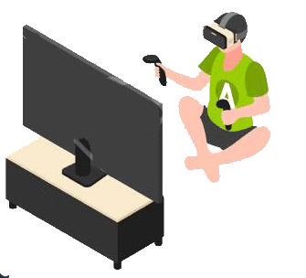
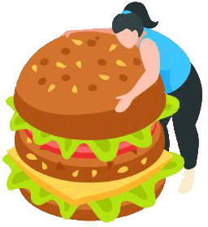
My Unhealthy Habits
1 Example: I drink soda everyday
2……………………………………………………………………………………….
3……………………………………………………………………………………...
4……………………………………………………………………………………...

2. Reflect on what you should do to change those unhealthy habits. Complete the table. Follow the example.
- Reflexiona acerca de lo que tú deberías hacer para cambiar esos hábitos no saludables. Completa la tabla. Sigue el ejemplo.
**todas las respuestas son correctas, pues son personales**

My unhealthy habits | Changes
Example: I skip breakfast | I should have breakfast everyday

3. Survey 4 members of your family or friends. Complete the table and give points according to it. Check the results.
- Haz una encuesta a cuatro miembros de tu familia o amigos. Completa la tabla y asigna puntajes según ésta. Revisa los resultados.

**todas las respuestas son correctas, pues son personales**

Always: Siempre | +6 points | Usually: Generalmente | +4 points | Almost never: Casi nunca | +2 points

Name | How often do you eat junk food? | How often do you do physical activity? | How often do you prepare healthy meals? | How often do you watch TV for more than 2 hours? | How often do you drink water? | How often do you play computer games for more than 3 hours? | Total
E.g. : Ricardo | Usually | Almost never | Usually | Almost never | Always | Usually | 22

Check the results!

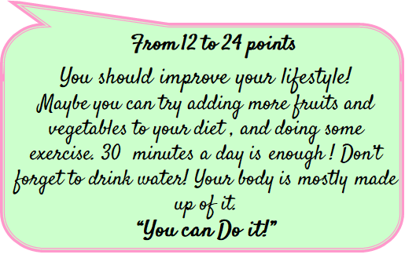
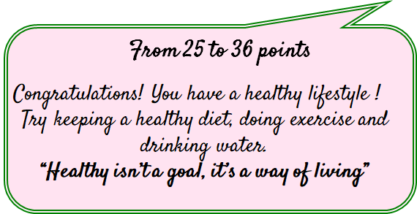

SECTION 4: EXTRA ACTIVITY
Taking care of our body and our mind
1. Write 3 statements to motivate your friends to take care of their body and their mind. Include images to illustrate.
- Escribe 3 enunciados para motivar a tus amigos a cuidar su cuerpo y su mente. Incluye imágenes para ilustrar.
**todas las respuestas son correctas, pues son personales**

 | “I practice yoga and I feel great, you should do it too”

“............................................................................................................................................................................................................................................................................................................................................................................................................................................”

“.............................................................................................................................................................................................................................................................................................................................................................................................................................................”

Share them with your friends through social media and  eodp_chile /  Students in Action.

SECTION 5: Digital Resources
Take a look at these links!
- https://www.healthlinkbc.ca/health-topics/
- Physical Activity for Children and Teens
- Helping Children With Disabilities Stay Active
- http://www.nourishinteractive.com/nutrition-games/childrens-educational-healthy-food-games
- Helping Your Child Build Inner Strength
NO OLVIDAR REPASAR EL CONTENIDO CON UN ADULTO

