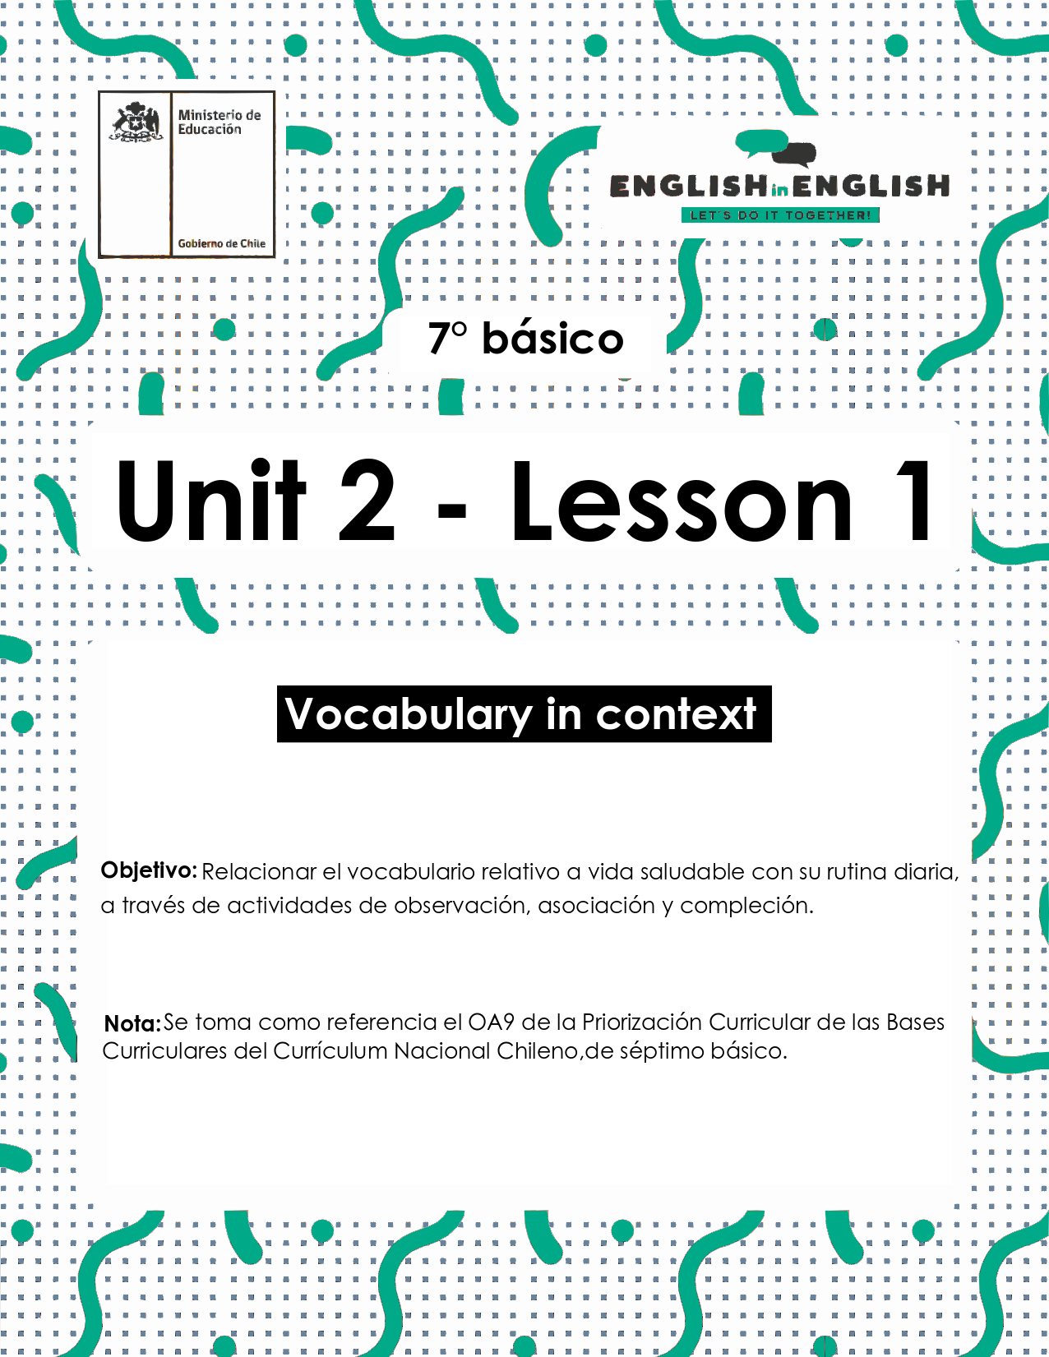

UNIT 2
LESSON 1

ÚTILES RECOMENDADOS:
- Texto del estudiante 7° básico.
- Cuaderno de inglés o 2 hojas en blanco.
- Lápiz grafito y goma.

SECTION 1: SETTING THE CONTEXT

Healthy Food

- Observe the images and answer the questions.
- Observa las imágenes y responde las preguntas.

a) What are they? 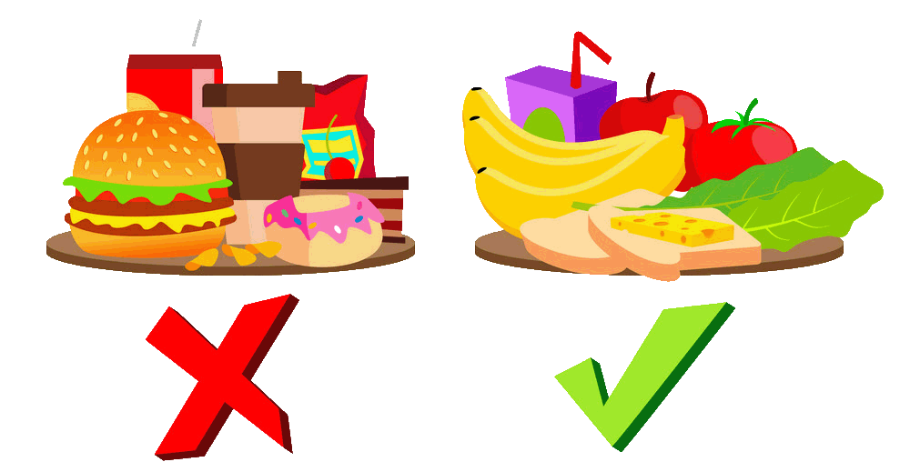 ___________________________________________
b) What do they represent? __________________________________________________________
c) What food items can you identify? Write them.
______________________________________________________________________________

- Read the descriptions about food and match them with the corresponding name.
- Lee las descripciones sobre comida y escribe el nombre que corresponde.

Healthy food / Unhealthy food

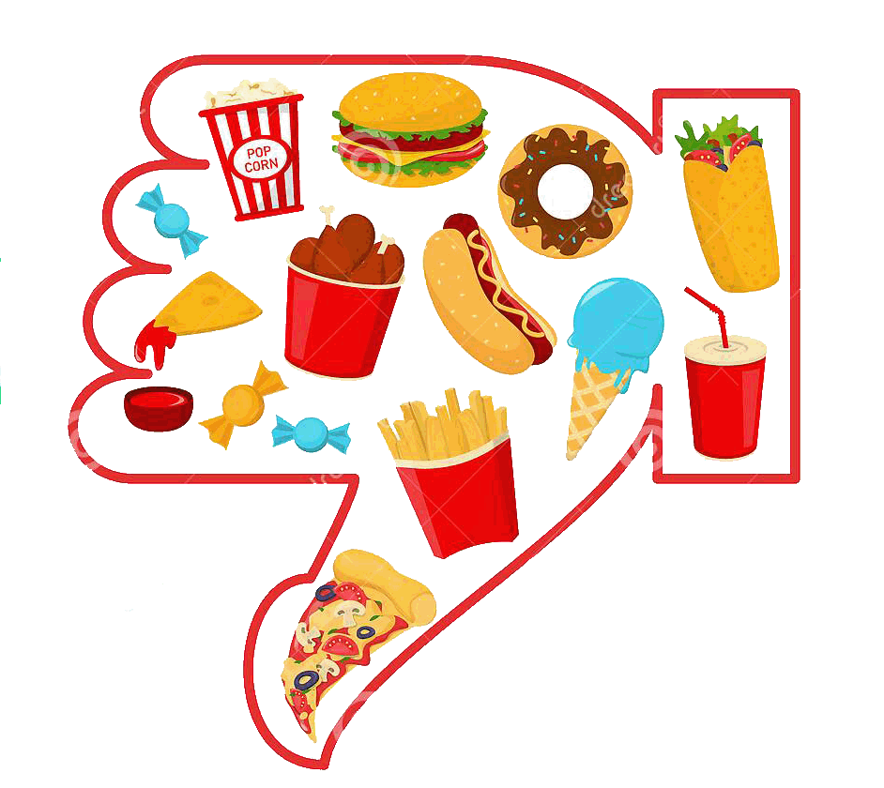

Food that is high in calories from sugar or fat, with little dietary fiber.

___________________________________________________

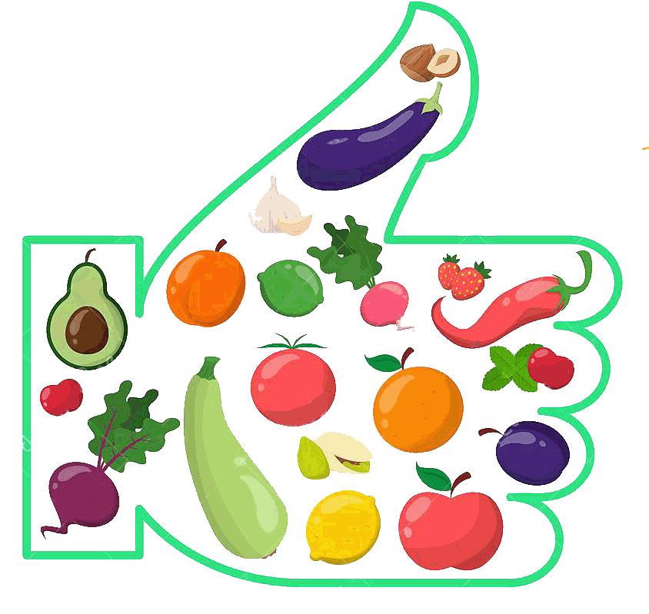

Food to be good for you because it does not contain artificial chemicals or much sugar or fat.
____________________________________________________________

- Mark the food item writing H for healthy food and U for unhealthy food.
- Marca el alimento con H si es saludable y U si es no saludable.
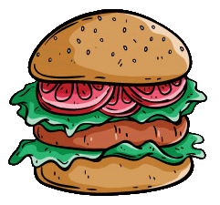 | 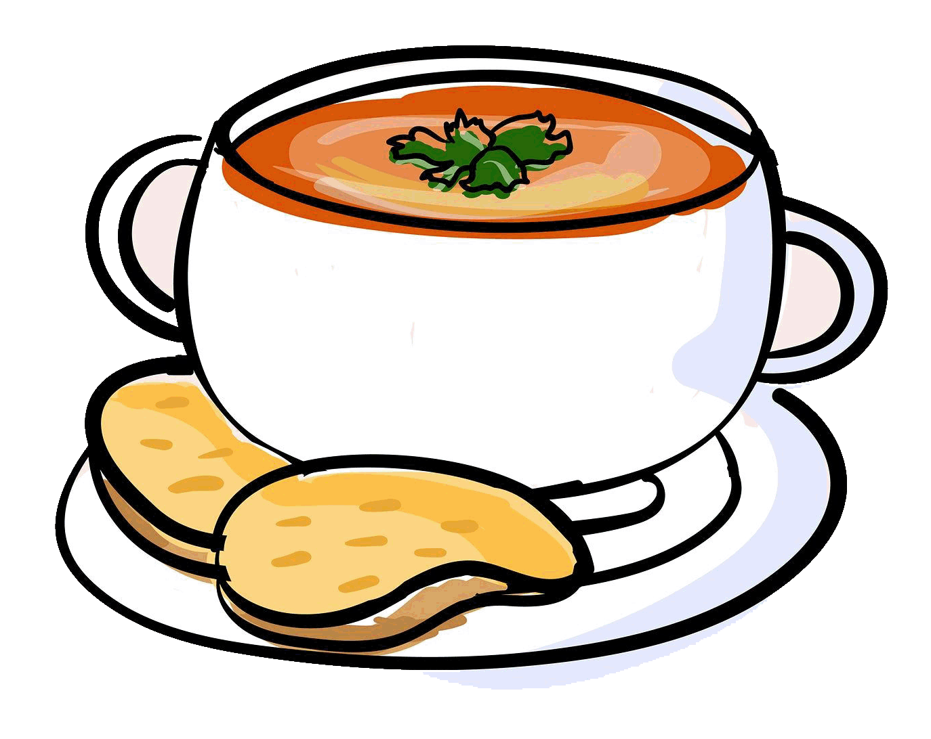 | 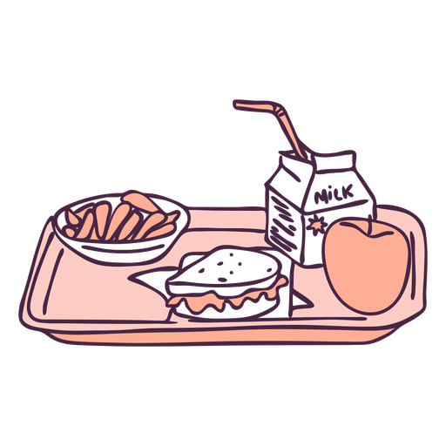 | 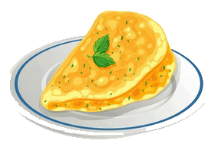
HAMBURGER | SOUP | BREAKFAST | OMELETTE

 |  | 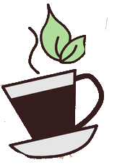 | 
APPLE PIE | A SODA | A CUP OF TEA | MILKSHAKE AND CROISSANT

SECTION 2: LET'S PRACTICE

Sergei´s Daily Routine

- Read the text below and underline all the food items you can find.
- Lee el texto y subraya todas las palabras relacionadas con alimentos que puedas encontrar.

My Daily Routine
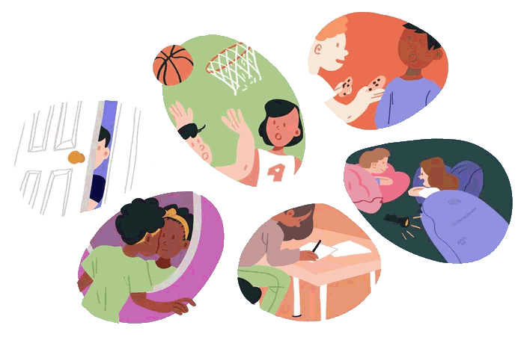
My name is Sergei. I´m fourteen years old. I always wake up at 7 o'clock every day except Sunday. I do morning exercises. I wash, clean my teeth, and comb my hair. Then I have breakfast. In the mornings I like to eat fried eggs or omelette, cheese sandwich and to drink tea. It takes me 10 minutes to get to school. My lessons begin at 8.30. At 2 o´clock the lessons are over. I usually have six or seven lessons a day. I return home at 2 o'clock and have rest. I watch TV and play computer games. I have lunch at 3 o'clock. For lunch, I usually eat some soup, fried or mashed potatoes with cutlets and a piece of cake with a cup of tea for dessert. Occasionally, after doing my homework I go for a walk with my friends. In the evening, I go to the gym. My training lasts for an hour. Dinner consists of fish, meat or chicken, vegetables or some salad and an apple pie. After dinner I read books, newspapers and magazines, chat with friends on the phone. At 10 o´clock I take a shower, brush my teeth and go to bed.

Frequency Adverbs
Always: Siempre
Usually: Usualmente
Occasionally: Ocasionalmente
Text taken and adapted from: https://en.islcollective.com/english-esl-worksheets/search/healthy+and+unhealthy+food

- Read the text again and complete the table below with the food Sergei eats for the different meals of the day.
- Lee el texto nuevamente y completa la tabla con los alimentos que Sergei consume para las diferentes comidas del día.

Breakfast
Lunch
Dinner

- Sergie’s daily routine includes time and different activities. Complete the table below and follow the example.
- Las rutinas diarias de Sergei incluyen horas y diferentes actividades. Completa la tabla de abajo, sigue el ejemplo.

Time | Activity
7 o´clock | Wake up

- Do you think Sergie has a healthy lifestyle? Why or Why not? Give 2 reasons.

_______________________________________________________________________________________

_______________________________________________________________________________________

SECTION 3: LET´S CONSTRUCT AND APPLY OUR KNOWLEDGE

My Daily Routine

- Complete the timetable with your daily routine.
Getting things done!
- Completa el horario con tu rutina diaria.

My day
8:00 I wake up  9:00  10:00  11:00  12:00  13:00  14:00 | 15:00  16:00  17:00  18:00  19:00  20:00  21:00

- Complete the charts with a healthy menu of your choice.
- Completa las tablas con un menú saludable de tu elección.

Choose your favorite day of the week: Monday Thursday
Tuesday Friday Wednesday

Saturday Sunday

Breakfast

Lunch

Dinner

SECTION 4: EXTRA ACTIVITY

Food and routine survey

- Survey to 4 members of your family or friends. Ask them the following questions.
- Haz una encuesta a cuatro miembros de tu familia o amigos. Hazle las siguientes preguntas.

- What time do you wake up?
- What is your favorite meal of the day?
- Do you prefer “healthy food” or “unhealthy food”, name 2 items according to your answer.
- Name 2 healthy food items you have in your fridge.
- What are your favorite activities? name 2.

Name | A- | B- | C- | D- | E-
E.g.: Mom: Clara | 08:45 | Lunch | Unhealthy  French fries  Soda | Milk  Eggs | Sleeping  Watching Tv
Total | 1. _______  2. _______  3. _______  4. _______ | 1. _______  2. _______  3. _______  4. _______ | 1. _______  2. _______  3. _______  4. _______ | 1. _______  2. _______  3. _______  4. _______ | 1. _______  2. _______  3. _______  4. _______

2. Check the survey results and write them down in your notebook.
- Revisa los resultados de la encuesta y escríbelos en tu cuaderno.
Example:
2 of my family/friends wake up at 8:00 every day AND 2 of my friends wake up at 10:00.

Take a look at these links!

- http://www.nourishinteractive.com/kids/healthy-games/24-my-plate-usda-five-food-groups-healthy-messages

- https://bdescolar.mineduc.cl/info/very-tasty-vegetable-recipes-00045841

NO OLVIDAR REPASAR EL CONTENIDO CON UN ADULTO

