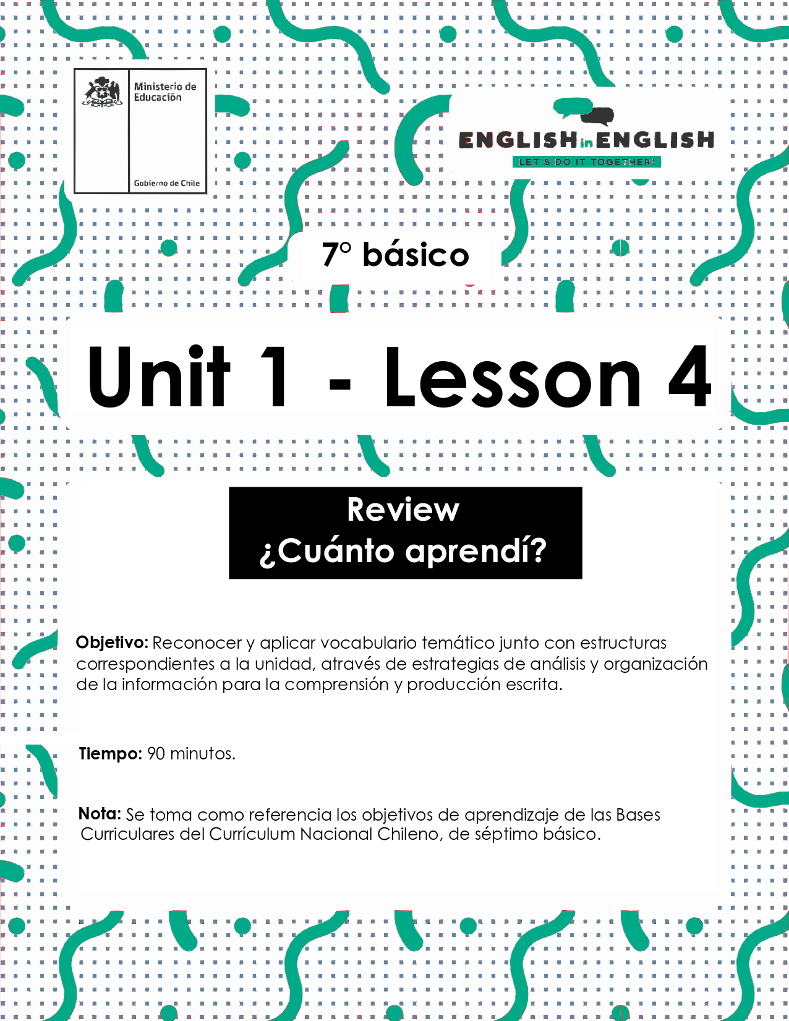

LESSON 4
REVIEW UNIT 1

ÚTILES
- Tu cuaderno de inglés y/u hojas en blanco
- Lápiz grafito, goma, regla.
- Marcadores de colores y/o lápices de colores.

ACTIVITIES: VOCABULARY (Tiempo estimado: 20 minutos)

- CIRCLE THE ANSWERS FOR THE FOLLOWING QUESTIONS.
- Encierra en un círculo las respuestas para las siguientes preguntas.

a) What are your favorite free time activities?

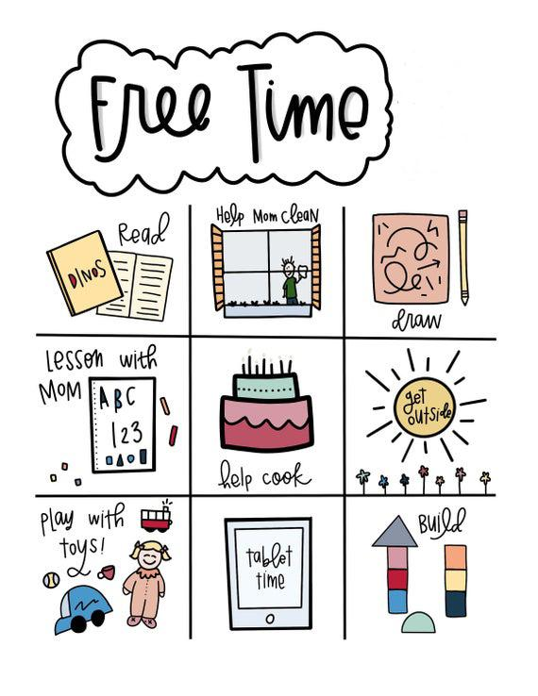

b) What are the most popular activities between your online friends?
 | 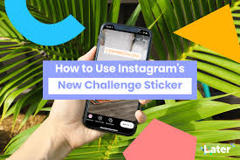 | 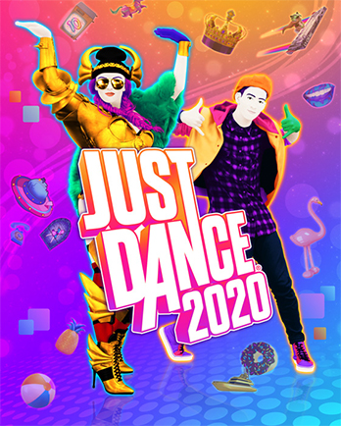
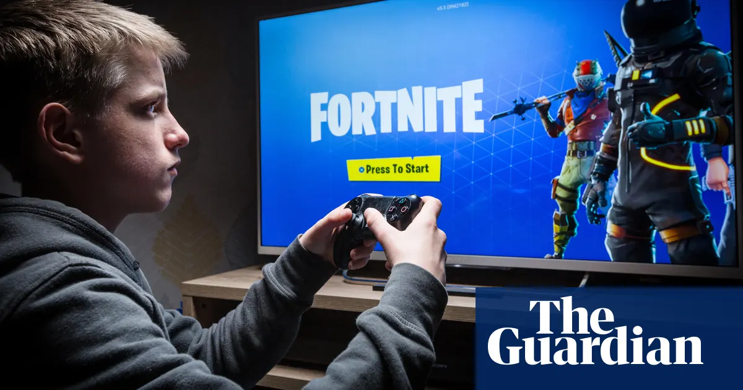 |  | 

c) How do you feel when you do your free time activities? Choose one feeling.
Happy | Optimistic | Hopeful | Angry | Sad | Embarrassed
 |  |  |  |  |  | 

- WRITE THE FEELINGS IN THE CORRECT COLUMN.
- Escribe los sentimientos en la columna correcta.

SAD LUCKY ANGRY

OPTIMISTIC CONFIDENT AFRAID

EXCITED ANNOYED
DELIGHTED EMBARRASSED

HOPEFUL FRIENDLY TERRIFIED

BORED HAPPY TIRED

POSITIVE FEELINGS 👍 | NEGATIVE FEELINGS 👎
1. Lucky | 1. Sad
2. | 2.
3. | 3.
4. | 4.
5. | 5.
6. | 6.
7. | 7.
8. | 8.
ACTIVITIES: BEFORE READING (Tiempo estimado: 15 minutos)

- OBSERVE THE IMAGES BELOW AND DISCUSS THE QUESTIONS...
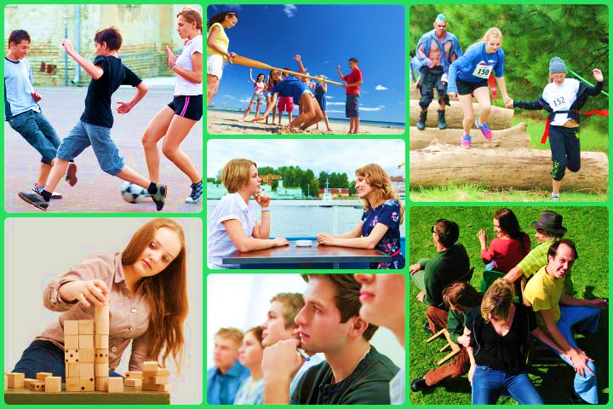
- Observa las imágenes de abajo y comenta las preguntas.

What feelings do the images communicate?

________________________________________

Which activity do you enjoy? Why?

_________________________________________

- READ THE TEXT.
- Lee el texto.

ACTIVITIES AND CHORES

School and homework. Activities and chores. Sleeping and eating. So much to
do in a single day! We asked some adolescents to tell us about the things they
can and can't do and how they feel about it.

Luis, 11, feels very happy because he says, “I have much time for friends. I like to talk to them on the computer and on the phone.”

Sandra feels annoyed like she never has enough time to practice her flute and hang out with friends. Instead, she’s always studying and doing homework.

Ana, 11, feels delighted because she says she loves herself as a very well-organized girl.

Greg, 12, feels angry because he wants to have more time to watch TV.

María, 12, feels relaxed because she says, “I have time to just rest, talk with my friends, write in my diary, and just plain sit around!”

And Ema, 12, feels very optimistic because she says she has very clear her future objectives.

vocabulary words
- Chores: Quehaceres
- Annoyed: Irritado
- Delighted: Encantada
- Rest: Descansar
- Flute: Flauta
Text taken and adapted from Programa de Estudio 7mo básico

ACTIVITIES: WHILE READING (Tiempo estimado: 15 minutos)
- READ THE TEXT AND ANSWER THE QUESTIONS:
- Lee el texto y responde las preguntas.

a) Why is Luis happy?

___________________________________________________

b) How old is Ana?

___________________________________________________

c) What kind of musical instrument does Sandra play?

___________________________________________________

- READ THE TEXT AND COMPLETE THE TABLE WITH THE CORRESPONDING FEELING:
- Lee el texto y completa la tabla con el sentimiento correspondiente.

ADOLESCENT | FEELING
LUIS
SANDRA
ANA
GREG
MARIA
ANA

ACTIVITY: AFTER READING (Tiempo estimado: 10 minutos)

- AFTER READING THE TEXT, WRITE 3 SENTENCES ABOUT YOURSELF FOLLOWING THE EXAMPLE.
- Después de leer el texto, escribe 3 oraciones acerca de ti mismo siguiendo el ejemplo:

Example: “Luis feels very happy because he has time for his friends”.
- I feel very happy because he has time for his friends.
1.-
2.-
3.-

ACTIVITIES: WRITING (Tiempo estimado: 30 minutos)

- INTERVIEW 3 FRIENDS OR PEOPLE YOU LIVE WITH.
ASK THEM QUESTIONS FROM THE CHART BELOW.
WRITE THEIR ANSWERS IN THE CHART BELOW.
- Entrevista 3 amigos o personas que vivan en el mismo lugar que tú
- (en línea si puedes, recuerda no acercarte a personas a menos de 1 metro de distancia).
- Haz las preguntas de la tabla.
- Escribe sus respuestas.

Questions | Answers
Questions | Friend 1 | Friend 2 | Friend 3
What is your favorite free time activity?
How do you feel doing this activity?
Name 3 others free time activities that you like | 1.  2.  3. | 1.  2.  3. | 1.  2.  3.

- USE THE ABOVE QUESTIONS TO WRITE A TEXT ABOUT YOUR FRIENDS.
ADD THEIR FAVORITE FREE TIME ACTIVITIES.
INCLUDE THE FEELINGS INVOLVED.
- Usa las preguntas de arriba para escribir un texto acerca de tus amigos.
- Agrega sus actividades de tiempo libre favoritas.
- Incluye los sentimientos involucrados.

1)_____________________________________
______________________________________
______________________________________

2)_____________________________________
______________________________________
______________________________________

3) _____________________________________
_______________________________________
_______________________________________

- EXPRESS YOUR PREFERENCES ABOUT FREE TIME ACTIVITIES.
FOLLOW THE EXAMPLE.
- Expresa tus preferencias acerca de las actividades de tiempo libre.
- Sigue el ejemplo.

Example:

I feel happy about football because it is fun. I feel bored playing tennis because I don’t like it.

____________________________________________________
____________________________________________________
____________________________________________________

EXTRA CURRICULAR ACTIVITY:

- Create a poster about the most common free time activities (3 or more) following the steps below.
Think of a title for your work.

- Crea un póster con las actividades de tiempo libre más comunes (3 o más) siguiendo los pasos de abajo.
- Piensa en un título para tu trabajo.

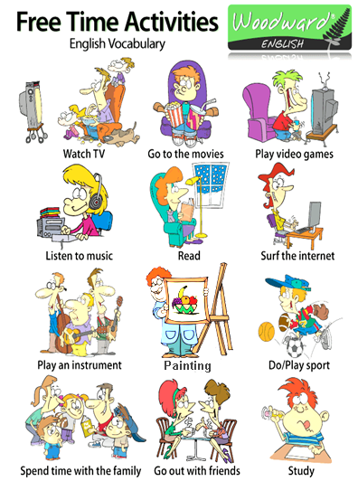

STEPS:

- Use images of the activities.
- Describe the feelings related to the activities.
- Write the title for your work.
- Express your preferences.
- Share and Present the poster to a friend.

