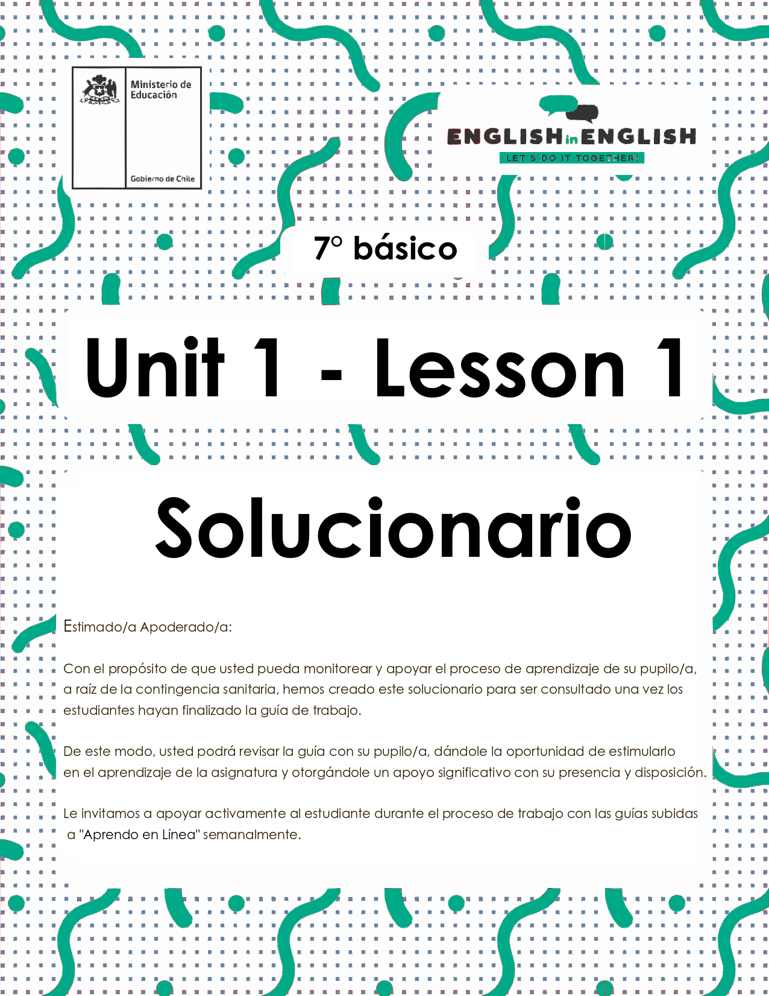

WEEK 1
VOCABULARY IN CONTEXT

ÚTILES
- Tu cuaderno de inglés y/u hojas en blanco.
- Lápiz grafito, goma, regla.
- Marcadores de colores y/o lápices de colores.

ACTIVITY 1: BEFORE READING, WHO IS SHE?

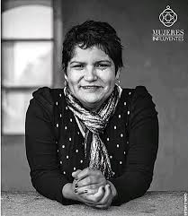
1. Complete the first 2 columns of the K W L chart.
- Completa los 2 primeros espacios del K W L cuadro.
- ¿Qué sabes? ¿Qué quieres saber? (¿Qué aprendiste? Se completa al final)
- Tiempo estimado: 20 minutos

K W L Chart
What I know | What I want to know | What I learned
She is a woman  She looks happy  … | About her life. | She is Carol Hullin.  She lived in La Legua.  She read the bible.  She worked as a paramedic assistant.  When Carol was 21 she moved to Australia and studied nursing at RMIT University.  She won a national scholarship to pursue a PhD in Health Informatics.  She became the first dean of Faculty of Health Sciences at the Catholic University of Temuco.  …

2. Now you can read her biography and complete the last column of the chart.
- Lee la biografía.
- Completa la tercera parte del organizador acerca de lo que aprendiste.
Carol Hullin was born on February 3rd, 1970 and grew up in a shantytown in La Legua, one of Santiago's most questioned and complicated areas. Her story was always a struggle; fighting hunger, against the cold weather and crime. Her parents were two teenagers and Carol had to manage on her own, selling candies on the public buses (Micros).
First, they lived in La Legua, one of the most complicated areas of Santiago. Then, her family moved to a shantytown in Florida and finally they settled in San Bernardo. There she became close to the Church for the first time in her life, when she was 14, she read The Bible.
She went to study at Caritas Chile, where she worked as a paramedic assistant. When she was 21 years old, an uncle living in Australia sent her a ticket and financial support. Carol set off to try her luck on the other side of the world.
There she went to study nursing at RMIT University, she did her clinical practice at an Australian hospital. While working there, she had to take care of Andrew, a young patient who was waiting for a kidney transplant; he later on became her husband and the father of her daughter Alayne (Elena, in honor of his mother).
Hullin won a national scholarship to pursue a PhD in Health Informatics and then completed a post-doctorate in Artificial Intelligence. Her resumé and work led her to be hired by the Australian Government to develop the country's first clinical computing center. Later, she moved to the World Bank to work in the improvement of access to health of the world's poorest population from the Computer Science area.
Carol returned to Chile and worked as an advisor for the Ministry of Education and completed a Master's degree in Law in Chile, which had as a purpose “to achieve decent treatment for people using telehealth and mobile technologies for their care”. In March of 2018, Carol Hullin became the first dean of the newly created Faculty of Health Sciences at the Catholic University of Temuco.
For a long time, Carol felt ashamed of telling her life story, but she now understands that her path of overcoming many difficulties is an inspiring example to others.
(Taken from https://mujeresbacanas.com/carol-hullin-1970/)
Vocabulary:
First: Primero
Then: Luego
Finally: Finalmente
While: Mientras
Later: Más tarde
Now: Ahora

ACTIVITY 2: WHILE READING

1. Read the text quickly.
Identify and underline the following key words/phrases in the text.
- Lee rápidamente el texto
- identifica y subraya las siguientes palabras/frases claves.
- Tiempo estimado: 10 minutos.
FIGHTING HUNGER | READ THE BIBLE | WORKED AS A PARAMEDIC ASSISTANT
SET OFF TO TRY HER LUCK | WON A NATIONAL SCHOLARSHIP | FELT ASHAMED

2. Read the Biography again. Match the key words/phrases with the corresponding emotion.
- Lee la biografía nuevamente.
- Relaciona las palabras/frases claves con la emoción correspondiente.
- Tiempo estimado: 10 minutos.
1. Read the bible
2. Worked as a paramedic assistant
3. Won a national scholarship
4. Felt ashamed
5. Fighting hunger
6. Set off to try LUCK

  N° 5 |  N° 3
 N° 4 |  N°1
 N° 2 |  N° 6

3. Read Carol Hullin´s Biography carefully and fill in the timeline using the connectors, in chronological order with the most important events and write a title for her story.
- Lee la biografía de Carol Hullin cuidadosamente.
- Completa la línea de tiempo, usando los conectores, en orden cronológico con los eventos y elige un nombre para su historia.
- Tiempo estimado: 20 minutos.

“AN INSPIRING WOMAN TO OTHERS”


First… Later… Then… While… Now… Finally...
She went to study at Caritas Chile
She set off to try her luck on the other side of the world.
She won a national scholarship.
She is the first dean of the newly created Faculty of Health Sciences at the Catholic University of Temuco.
Carol and her family lived in la Legua.
She understands that her path of overcoming many difficulties.

ACTIVITY 3: AFTER READING

v
1. Choose a famous character you admire today, find out information about him/her and complete the timeline below.
- Elige un personaje famoso que admires.
- Investiga acerca de su vida y completa la línea de tiempo.
- Tiempo estimado: 20 minutos


Then in Chillán Violeta started singing and playing the guitar, together with her siblings

In 1952, she travelled throughout Chile to record the breadth of Chilean folk music.
Later, in1927 her family moved to Chillán.
She composed “Gracias a la Vida” in La Paz in 1966. She died on 5 February 1967.
Violeta Parra Sandoval was born in San Carlos, Ñuble Province, on 4 October 1917.
Now, she is acknowledged as "the Mother of Latin American folk"

ACTIVITY 4: EXTRACURRICULAR

1. Read the following quote and reflect about it, pay attention to your emotions.
- Lee la siguiente oración, reflexiona sobre esta y pon atención a tus emociones.
- Tiempo estimado: 10 minutos.
“REFLEXION: RESPUESTAS ABIERTAS”
“Believe in yourself and all that you are. Know that there is something inside you that is greater than any obstacle”

